**Using Blood Tests to Identify Babies**

**I. Were the babies switched?**

Two couples had babies in the same hospital at the same time. Michael and Danielle had twins, a boy, Michael, Jr., and a girl, Michelle. Denise and Earnest had a girl, Tonja. Danielle was convinced that there had been a mix-up and she had the wrong girl, since Michael Jr. and Tonja were both light-skinned, while Michelle had darker skin. Danielle insisted on blood type tests for both families to check whether there had been a mix-up. In order to interpret the results of the blood type tests, you will need to understand the basic biology of blood types.

 kck1osrs%5b1%5d 

**Blood Types**

There are many different ways to classify blood types, but the most common blood type classification system is the ABO (said "A-B-O") system. There are four blood types in the ABO system: Type A, Type B, Type AB, and Type O. These blood types refer to different versions of carbohydrate molecules (complex sugars) which are present on the surface of red blood cells.

|  |  |  |
| --- | --- | --- |
| **People with**: | **Have:** | |
| Type A blood | Type A carbohydrate molecules  on their red blood cells | a-cell copy |
| Type B blood | Type B carbohydrate molecules  on their red blood cells | b-cell copy |
| Type AB blood | Type A and B carbohydrate molecules  on their red blood cells | ab-cell copy |
| Type O blood | Neither A nor B carbohydrate molecules  on their red blood cells | o-cell copy |

The Type A and Type B carbohydrate molecules are called **antigens** because they can stimulate the body to produce an immune response, including antibodies. **Antibodies** are special proteins that travel in the blood and help our bodies to destroy viruses or bacteria that may have infected our bodies (see figure on next page).

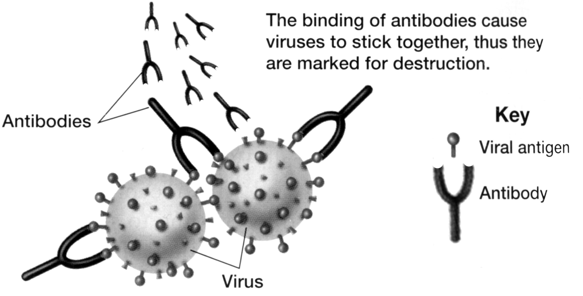

Adapted from Figure 40.5 in Holt Biology by Johnson and Raven

Normally, our bodies do not make antibodies against any molecules that are part of our own bodies. Thus, antibodies help to defend against invading viruses and bacteria, but normally antibodies do not attack our own body cells.

For example, people with Type A blood do not make antibodies against the Type A antigen which is present on their red blood cells. However, they do make antibodies against the Type B antigen (called anti-B antibodies).

★ Test your understanding of blood groups by filling in the blanks in the chart below.

|  |  |
| --- | --- |
| image006 | Blood group A  If you belong to the blood group A, you have A antigens on the surface of your red blood cells and ________ antibodies in your blood. |
| image008 | Blood group B  If you belong to the blood group B, you have B antigens on the surface of your red blood cells and ________ antibodies in your blood. |
| image010 | Blood group AB  If you belong to the blood group AB, you have both A and B antigens on the surface of your red blood cells and no anti-A or  anti-B antibodies in your blood. |
| image012 | Blood group O  If you belong to the blood group O, you have neither A nor B antigens on the surface of your red blood cells, but you have both  ________ and ________ antibodies in your blood. |

**Blood transfusions — who can receive blood from whom?**

If you are given a blood transfusion that does not match your blood type, antibodies present in your blood can react with the antigens present on the donated red blood cells. For example, if a person who has Type A blood is given a Type B blood transfusion, then this person's anti-B antibodies will react with the Type B antigens on the donated red blood cells and cause a harmful reaction. This reaction can cause the donated red blood cells to burst and/or clump together and block blood vessels. This type of transfusion reaction is illustrated in the following drawing.

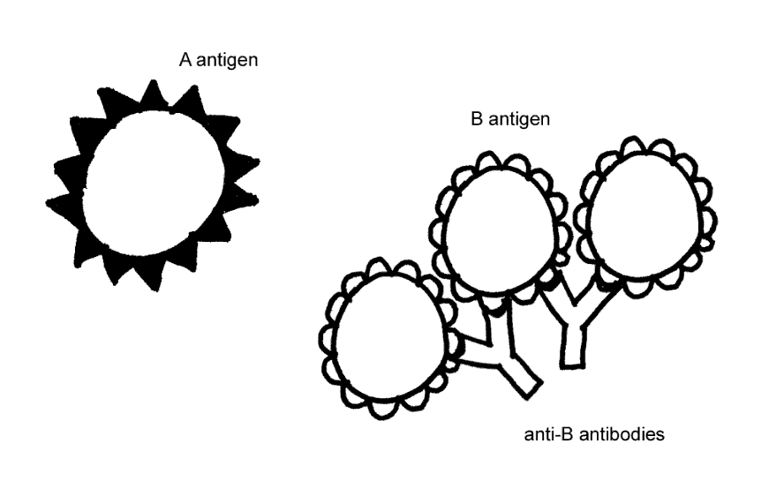

Transfusion reactions can be fatal. To prevent this from happening, doctors test whether a person's blood is compatible with the donated blood before they give a transfusion. A person can only be given donated blood with red blood cells that do not have any antigen that can react with the antibodies in the person's blood.

★ Test your understanding of blood groups by completing the table below.

|  |  |  |  |  |
| --- | --- | --- | --- | --- |
| **Blood Group** | **Antigens on red blood cells** | **Antibodies in plasma** | **Can receive**  **blood from** | **Can give**  **blood to** |
| A | A | Anti-B | A and O | A and AB |
| B | B |  |  |  |
| AB | A and B |  |  |  |
| O | None |  |  |  |

★ Which blood type would be considered a universal donor (someone who can give blood to anyone)?

**Genetics of Blood Types**

Your blood type was established before you were born, by genes inherited from your mother and father. This blood type gene has three different versions or alleles that code for different versions of a protein enzyme as follows:

The **IA** allele codes for a version of the enzyme that puts Type A carbohydrate molecules on the red blood cells.

The **IB** allele codes for a version of the enzyme that puts Type B carbohydrate molecules on the red blood cells.

The ***i*** allele codes for an inactive version of the enzyme, so red blood cells have neither type of carbohydrate molecule on their surface.

Everyone has two copies of these genes, so there are six possible combinations of alleles (called genotypes) which result in the four possible blood types (phenotypes):

**IA** **IA** and **IA *i*** - both resulting in Type A blood,

**IB IB** and **IB *i*** - both resulting in Type B blood,

**IA** **IB** - resulting in Type AB blood,

***i i*** - resulting in Type O blood.

★ In a heterozygous **IA *i*** person, which allele is dominant, **IA** or ***i***? Explain your reasoning.

**Codominance** refers to inheritance in which two alleles of a gene each have a different observable effect on the phenotype of a heterozygous individual. Thus, in codominance, neither allele is recessive—both alleles are dominant.

★ Which one of the genotypes shown above results in a phenotype that provides clear evidence of codominance? Give the genotype and draw a picture of a red blood cell for this genotype to illustrate how both alleles influence blood type in this case.

★ Each biological parent gives one of their two ABO alleles to their child. For example, a father who has blood type AB has the genotype_____, so he will produce sperm with either an **IA** or an **IB** allele and he can give either an **IA** or an **IB** allele to a child of his. If the mother has blood type O, her genotype must be _____, and she can only give an ______ allele to a child of hers.

★ The Punnett Square below shows the possible genotypes for the children of these parents. Write in the blood type for each genotype to show the possible blood types for the children of these parents.

|  |  |  |  |
| --- | --- | --- | --- |
| **Father**  **(Type AB)**  Sperm | **Mother**  **(Type O)**  Eggs | | |
|  | ***i*** | ***i*** |
| **IA** | **IA** ***i*** | **IA** ***i*** |
| **IB** | **IB** ***i*** | **IB** ***i*** |

**Were the babies switched?**

Now you are ready to evaluate whether Earnest and Denise's baby girl was switched with Michael and Danielle's baby girl. The following family trees show the blood types for each person in both families.

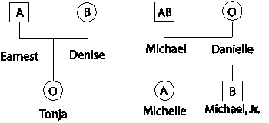

★ Is it possible for Michael and Danielle to have a child who has type O blood? How do you know this? (Hint: Use the Punnett square on the previous page to help you to answer these questions.)

★ To check whether Earnest and Denise could have a baby with Type O blood, draw a Punnett square for a father who has blood Type A and genotype **IA *i*** and a mother who has blood Type B and genotype **IB *i***. Write in the blood type for each child's genotype.

★ Was a switch made at the hospital? Explain your reasoning.

**Universal Donors and Universal Recipients**

|  |  |  |  |  |
| --- | --- | --- | --- | --- |
|  |  | **Recipients** |  |  |
| **Donors** | **Type A** | **Type B** | **Type AB** | **Type O** |
| **Type A** |  |  |  |  |
| **Type B** |  |  |  |  |
| **Type AB** |  |  |  |  |
| **Type O** |  |  |  |  |

**As you watch the demonstration:**

1. Place a “check” if you witness no color change (donation was successful)
2. Place an “X” if you do witness a color change (donation was not successful)

**Analysis:**

Based on the data above, which blood type can donate blood to any other blood type? How do you know?

Based on the data above, which blood type can receive blood from any other blood type? How do you know?