Characteristics of Life Crossword

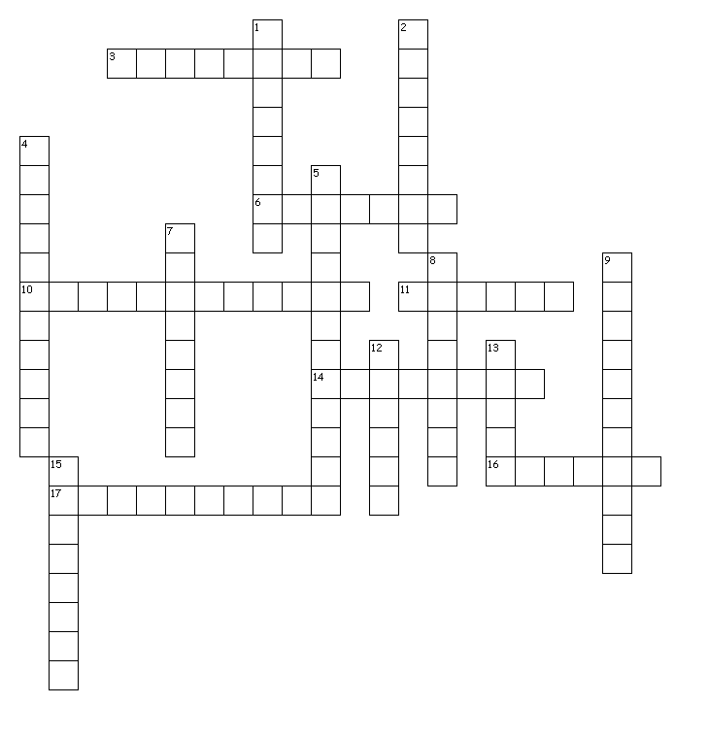

Across
3. an "effect"
6. the type of reproduction that uses the same genetic information to make a copy
10. can be simple such as in one cell or complex like how organs work together in an organ system
11. an increase in mass or weight
14. must eat to survive
16. the type of reproduction that exchanges genetic information
17. any inherited characteristic that results from changes to a species over time

Down
1. type of environment inside of the organism
2. type of environment outside of the organism
4. a change in abilities
5. the production of offspring
7. a "cause"
8. makes its own food
9. maintaining its internal environment
12. what all living things use for "fuel"
13. what all living things are made of
15. an example of something living that is made of one cell

List the 8 Characteristics of Life
1.
2.
3.
4.
5.
6.
7.
8.

