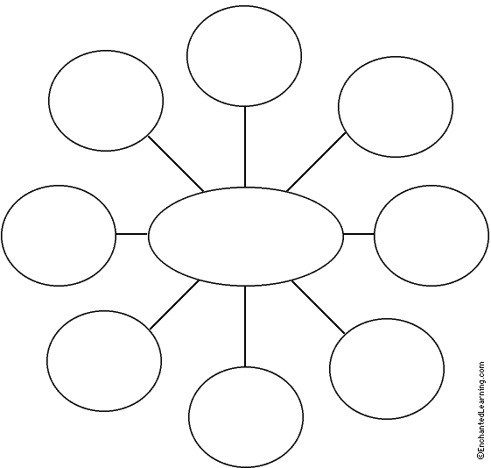
Characteristics of Life Graphic Organizer
Directions: Fill in each bubble with one of the 8 characteristics of life from our class notes. Then draw lines from each characteristic, listing key vocabulary words from that section.

