Name_______________________________________Date______________________Period__________
Problem of the Week (POW) #1: Characteristics of Life
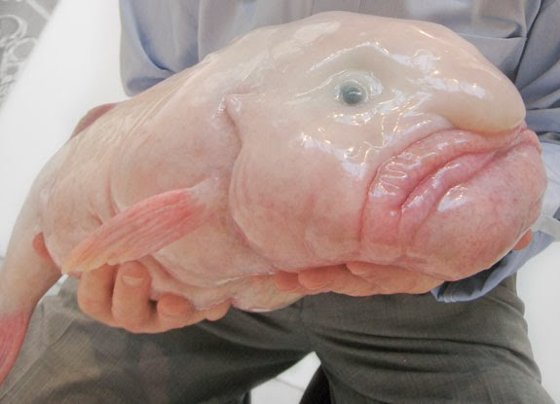
Situation:
Is it alive!? Above is a photograph of a never before seen creature from the sea. Professor Buster Tran of Princeton, New Jersey claims to be the first to discover this rare species. Scientists are skeptical, however, and are scrambling to determine if the creature is considered living or not. There is a suspicion that this creature may have been created by a former Hollywood special effects artist.
Task:
Below are the 8 characteristics of life we have reviewed in 8th grade science this year. Your task is to design a series of experiments that would prove or disprove the discovery as a brand new species. There are 8 possible quiz grade points available for this POW (one point for each experiment)
Ex. Made of Cells
Experiment: Take a small sample of the organism’s skin and observe it under a microscope
Positive (alive) test result: A scientist would be able to observe cells on the microscope slide
Negative (not alive)test result: A scientist would not be able to observe cells on the microscope slide

- Made of Cells (1 point)
  - Experiment:__________________________________________________________________________________________________________________________________________________________________________________________________________________________________________________________________________________________________
  - Evidence of Positive test result: ______________________________________________________________________________________________________________________________________________________
  - Evidence of Negative test result: ______________________________________________________________________________________________________________________________________________________
- Displays Organization (1 point)
  - Experiment:__________________________________________________________________________________________________________________________________________________________________________________________________________________________________________________________________________________________________
  - Evidence of Positive test result: ______________________________________________________________________________________________________________________________________________________
  - Evidence of Negative test result: ______________________________________________________________________________________________________________________________________________________
- Requires Energy (1 point)
  - Experiment:__________________________________________________________________________________________________________________________________________________________________________________________________________________________________________________________________________________________________
  - Evidence of Positive test result: ______________________________________________________________________________________________________________________________________________________
  - Evidence of Negative test result: ______________________________________________________________________________________________________________________________________________________

- Grows and Develops (1 point)
  - Experiment:__________________________________________________________________________________________________________________________________________________________________________________________________________________________________________________________________________________________________
  - Evidence of Positive test result: ______________________________________________________________________________________________________________________________________________________
  - Evidence of Negative test result: ______________________________________________________________________________________________________________________________________________________
- Reproduces (1 point)
  - Experiment:__________________________________________________________________________________________________________________________________________________________________________________________________________________________________________________________________________________________________
  - Evidence of Positive test result: ______________________________________________________________________________________________________________________________________________________
  - Evidence of Negative test result: ______________________________________________________________________________________________________________________________________________________
- Responds to Stimuli (1 point)
  - Experiment:__________________________________________________________________________________________________________________________________________________________________________________________________________________________________________________________________________________________________
  - Evidence of Positive test result: ______________________________________________________________________________________________________________________________________________________
  - Evidence of Negative test result: ______________________________________________________________________________________________________________________________________________________

- Maintains Homeostasis (1 point)
  - Experiment:__________________________________________________________________________________________________________________________________________________________________________________________________________________________________________________________________________________________________
  - Evidence of Positive test result: ______________________________________________________________________________________________________________________________________________________
  - Evidence of Negative test result: ______________________________________________________________________________________________________________________________________________________
- Adapts and Evolves (1 point)
  - Experiment:__________________________________________________________________________________________________________________________________________________________________________________________________________________________________________________________________________________________________
  - Evidence of Positive test result: ______________________________________________________________________________________________________________________________________________________
  - Evidence of Negative test result: ______________________________________________________________________________________________________________________________________________________

Resources for this POW (MrTranScience.Weebly.com/documents.html)
- Characteristics of Life Powerpoint
- Characteristics of Life Crossword (with answer key)
- Characteristics of Life Review Game
**As always, see Mr. Tran for help after school**

