Types of Energy Notes
- Heat Energy
  - _____________________ particles produce heat
  - Heat energy can be produced by ______________________ (rubbing together)
  - Heat energy causes changes in ____________________ and phase (solid, liquid, gas) of any form of matter
- Chemical energy
  - Required to ____________ atoms together (like sugar is needed to make ATP from ADP; a bond with phosphate is created)
  - When bonds are ____________________ energy is ______________________
  - ____________ and ______________ are forms of ________________ chemical energy
- Electromagnetic Energy
  - Power lines carry electromagnetic energy into your home in the form of ____________________
  - ___________________ is a form of electromagnetic energy (including sunlight)
  - Each color of light (think back to the light spectrum and prisms) represents a different amount of _________________________ energy
  - Electromagnetic energy is also carried by __-rays, ____________ waves, and ______________ light
- Nuclear Energy
  - The _________________ of an atom is the source of nuclear energy
  - When the nucleus ___________ (fission), nuclear energy is ___________________ in the form of ___________ energy and _______________ energy
  - Nuclear energy is also released when nuclei ________________ at high speeds and ________ (fuse)
  - The sun’s energy is produced from a ________________ __________________ reaction in which ____________________ nuclei fuse (bond together) to form helium nuclei
  - The most ________________________form of energy is nuclear energy

- Mechanical Energy
  - When work is done to an object, it acquires energy
  - The energy it acquires is known as ______________________ _________________
  - When you kick a football, you ________ mechanical energy to the football to make it move
3 Important facts about Energy
- Energy is the ability to do ___________
- Energy cannot be _________________ or _____________________, it may only be ____________________ from one form to another
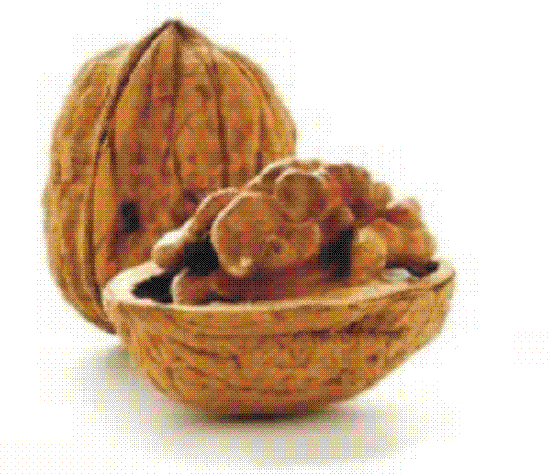
- All living organisms require __________________ (characteristics of life) in order to carry out life processes; all cells require energy to carry out ________ processes
What we should know so far in a…
Photosynthesis
- Done by __________________ (producers) to obtain ______________ (ability to do work)
- ______________ energy (_______________ bonds) from the sun in the form of _______________ (C₆H₁₂O₆)
- Energy transformation =______________________energy -> ______________________ energy
Cell Respiration
- Done by ______________________ (consumers and decomposers)
- Using _______________ (food) and __________________ (breathing) cells of heterotrophs “charge their batteries”
- ADP = adenosine diphosphate (A-P-P) = “___________ battery”
- ATP = adenosine triphosphate (A-P-P-P) = “________________ battery”
- Therefore, for our cells to do __________, we must consume food (sugar) that allows our cells to add phosphate to ADP to make ATP which means that the cell’s battery is charged and ready to do work
- More simply, cell respiration uses sugar from the food we eat to let our cells do work!

