Food Chains and Food Webs
Close reading: Draw a box around important words/terms. Circle words that are confusing/brand new. Make notes in the margins to clarify each paragraph. Add thinking notes (if necessary)
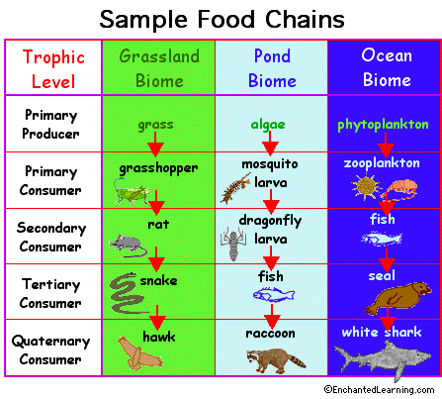
Every organism needs to obtain energy in order to live. For example, plants get energy from the sun, some animals eat plants, and some animals eat other animals.
A food chain is the sequence of energy flow in a biological community (an ecosystem) to obtain nutrition. A food chain starts with the primary energy source, usually the sun or boiling-hot deep sea vents. The next link in the chain is an organism that makes its own food from the primary energy source -- an example is photosynthetic plants that make their own food from sunlight (using a process called photosynthesis) and chemosynthetic bacteria that make their food energy from chemicals in hydrothermal vents. These are called autotrophs or primary producers.
Next come organisms that eat the autotrophs; these organisms are called herbivores or primary consumers -- an example is a rabbit that eats grass.
The next link in the chain is animals that eat herbivores - these are called secondary consumers -- an example is a snake that eat rabbits.
In turn, these animals are eaten by larger predators -- an example is an owl that eats snakes.
The tertiary consumers are are eaten by quaternary consumers -- an example is a hawk that eats owls. Each food chain end with a top predator, and animal with no natural enemies (like an alligator, hawk, or polar bear).
The arrows in a food chain show the flow of energy, from the sun or hydrothermal vent to a top predator. As the energy flows from organism to organism, energy is lost at each step. A network of many food chains is called a food web.
Trophic Levels:
The trophic level of an organism is the position it holds in a food chain.
- Primary producers (organisms that make their own food from sunlight and/or chemical energy from deep sea vents) are the base of every food chain - these organisms are called autotrophs.
- Primary consumers are animals that eat primary producers; they are also called herbivores (plant-eaters).
- Secondary consumers eat primary consumers. They are carnivores (meat-eaters) and omnivores (animals that eat both animals and plants).
- Tertiary consumers eat secondary consumers.
- Quaternary consumers eat tertiary consumers.
- Food chains "end" with top predators, animals that have little or no natural enemies.
When any organism dies, it is eventually eaten by detrivores (like vultures, worms and crabs) and broken down by decomposers (mostly bacteria and fungi), and the exchange of energy continues.
Some organisms' position in the food chain can vary as their diet differs. For example, when a bear eats berries, the bear is functioning as a primary consumer. When a bear eats a plant-eating rodent, the bear is functioning as a secondary consumer. When the bear eats salmon, the bear is functioning as a tertiary consumer (this is because salmon is a secondary consumer, since salmon eat herring that eat zooplankton that eat phytoplankton, that make their own energy from sunlight). Think about how people's place in the food chain varies - often within a single meal.

Numbers of Organisms:
In any food web, energy is lost each time one organism eats another. Because of this, there have to be many more plants than there are plant-eaters. There are more autotrophs than heterotrophs, and more plant-eaters than meat-eaters. Although there is intense competition between animals, there is also an interdependence. When one species goes extinct, it can affect an entire chain of other species and have unpredictable consequences.
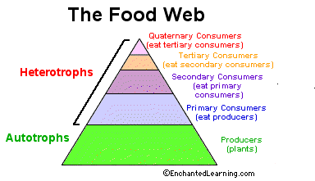

Equilibrium
As the number of carnivores in a community increases, they eat more and more of the herbivores, decreasing the herbivore population. It then becomes harder and harder for the carnivores to find herbivores to eat, and the population of carnivores decreases. In this way, the carnivores and herbivores stay in a relatively stable equilibrium, each limiting the other's population. A similar equilibrium exists between plants and plant-eaters.

